Coding Challenge Day 3 (Week 1) - 1Q
-By galeti mohammad hussain

## Problem Statement

# StudentManagement Spring 1
## Problem Statement
Spring Flowers school wants to manage their students online:-
## User Stories :-
1. As a student. I should be able to see the Welcome page of my application.
2. As a Student. I should be able to see a MENU bar and School logo
3. As a Student. I should be able to see my information after clicking Profile Button
## Instructions:-
1. Please use HTML 5 and CSS 3 concepts
2. Try to make a proper application
3. Deploy the application on http server

Solution:

HTML code:

<!DOCTYPE html>
<html lang="en">
<head>
<meta charset="UTF-8">
<title>Spring Flowers School</title>
<link rel="stylesheet" href="DAY3STYLE.CSS">
</head>
<body>

<<header>
<div class="logo-container">
<img src="https://tinyurl.com/logo12873546" alt="School Logo" class="school-logo">
<span class="school-name">Spring Flowers school</span>
</div>

<nav>
<ul>
<li><a href="#">Home</a></li>
<li><a href="#" onclick="showProfile()">Student Profile</a></li>
<li><a href="#">Contact</a></li>
</ul>
</nav>
</header>

<section class="welcome">
<h1>Welcome to Student Management System</h1>
</section>

<section id="profileSection" class="profile hidden">
<div class="student-image">
<img src="https://tinyurl.com/studentimage4" alt="Student Image">
</div>

<div class="student-info">
<h2>Student Information</h2>
<p><strong>Name:</strong> HUSSAIN</p>
<p><strong>Class:</strong> 10th Grade</p>
<p><strong>Roll No:</strong> 30</p>
<p><strong>Email:</strong> hussain7@gmail.com</p>
<p><strong>9th standard marks:</strong> 85%</p>
</div>
</section>

<script>
function showProfile() {
document.getElementById("profileSection").classList.remove("hidden");
}
</script>

</body>
</html>

CSS code:

* {
margin: 0;
padding: 0;
box-sizing: border-box;
font-family: Arial, sans-serif;
}

body {
background-color: #f0f0f0;
}

header {
background-color: #43a0bd;
padding: 15px;
display: flex;
justify-content: space-between;
align-items: center;
}

.logo {
font-size: 20px;
font-weight: bold;
}

nav ul {
list-style: none;
display: flex;
gap: 20px;
}

nav ul li a {
text-decoration: none;
color: black;
font-weight: 500;
}

nav ul li a:hover {
color: white;
}

.welcome {
text-align: center;
padding: 40px;
}

.profile {
margin: 30px auto;
width: 70%;
background-color: #be3b3107;
padding: 30px;
display: flex;
gap: 40px;
border: 2px solid #b9b84daf;
}

.student-image img {
border-radius: 50%;
border: 2px solid black;
}

.student-info h2 {
margin-bottom: 15px;
}

.hidden {
display: none;
}
.school-name {
font-size: 34px;
font-weight: bold;
}

OUTPUT/VIEW:
1.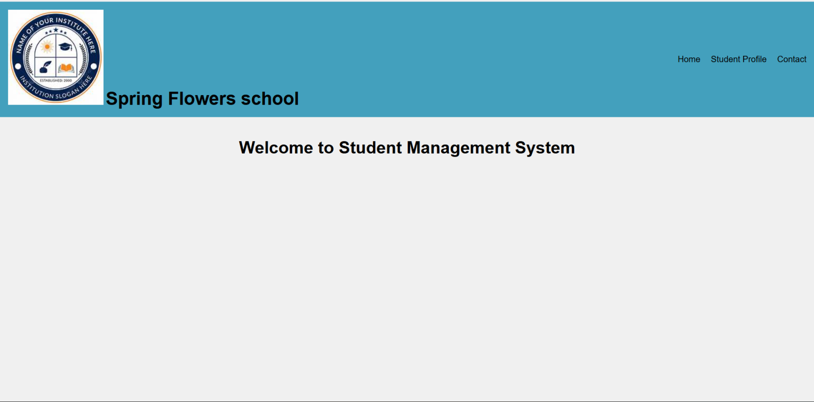

2.
